MA 2611 Lab 4

Xin Yu Wu

2024-09-30

**STANDARDS BEING REVISED: L.17**

**L.11 and L.13**

#a) X ∼ Poisson(10)   
  
#Randomly generate and store a sample of n = 2000 values of X  
randomSample <- rpois(2000, 10)  
  
#Finding Estimate:  
mean(randomSample < 8)

## [1] 0.2275

mean(randomSample >= 8 & randomSample < 9)

## [1] 0.101

#Finding exact:  
sum(dpois(0:7,10))

## [1] 0.2202206

sum(dpois(8:8,10))

## [1] 0.112599

The estimated probability using the randomly sampled data is: P(X < 8) = 0.2175 and P(8 <= X < 9) = 0.107. The exact probability using the formula we learned in class is: P(X < 8) = 0.2202206 and P(8 ≤ X < 9) = 0.112599. In this case, the estimated values are close but different from the exact probabilities. for P(X < 8), the probabilities differs at the hundredth place. For P(8 ≤ X < 9), the probabilities also differ at the hundredth place.

lambda <- 10  
#b)  
  
#Calculate the expected value and standard deviation for X  
mean(randomSample)

## [1] 10.0835

sd(randomSample)

## [1] 3.259577

#Calculate exact expected value and standard deviation using formulas  
exactStandardDeviation <- lambda  
print(exactStandardDeviation)

## [1] 10

sqrt(lambda)

## [1] 3.162278

The estimated expected value and standard deviation for X is 10.1185 and 3.232442, respectively. The exact expected value and standard deviation using the formulas we learned in class is 10 and 3.162278, respectively. We can see that the probabilities from the estimate and expected are very similar but different. For instance, for expected value, the estimated probability and the exact expected value differ at the tenth place. Similarly, for standard deviation, the estimated and exact probability differ also at the tenth place.

#c)  
freqDataFrame <- as.data.frame(table(randomSample))  
  
colnames(freqDataFrame) <- c("X", "Frequency")  
  
# Create the bar graph  
ggplot(data =freqDataFrame, aes(x = X, y = Frequency)) +  
 geom_bar(stat = "identity", fill = "lavender", color = "seagreen") +  
 labs(title = "Distribution of Sample from Poisson(10)",  
 x = "Value of X",  
 y = "Frequency")

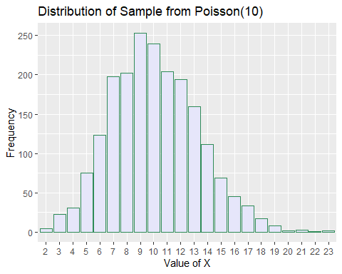

**Problem L.14**

#X ∼ Binomial(12, 0.67)   
  
# a. P (X > 14)  
answerA <- 1-sum(dbinom(0:14 , 12, 0.67)) #answer is 0 on calc  
print(answerA)

## [1] 2.220446e-16

# b. P (7 < X ≤ 10)  
answerB <- sum(dbinom(8:10, 12, 0.67)) #cwc checked with calc  
print(answerB)

## [1] 0.5844876

# c. P (X ≤ 11)  
answerC <- sum(dbinom(0:11, 12, 0.67)) #cwc  
#pbinom(11, 12, .67, lower.tail = T)  
  
print(answerC)

## [1] 0.9918173

**Problem L.15**

#X ∼ Poisson(6.4)  
  
#a. P (X ≤ 4)  
poissonA <- ppois(4,6.4) #calc  
# double checking: sum (dpois(0:4, 6.4))  
print(poissonA)

## [1] 0.23507

#b. P (7 ≤ X < 8)  
poissonB <-sum(dpois(7:7,6.4)) #calc  
print(poissonB)

## [1] 0.1449922

#c. P (X ≥ 9)  
poissonC <- 1- sum(dpois(0:8,6.4)) #calc  
#1-ppois(8,6.4)  
print(poissonC)

## [1] 0.1966852

**Problem L.8 and L.16.**

#a) X ∼ Normal(100, 81)   
#Generate random sample  
randomSampleNorm <- rnorm(2000,100, sqrt(81))  
  
mean(randomSampleNorm >= 72)

## [1] 0.9995

mean(randomSampleNorm >= 90 & randomSampleNorm <= 95)

## [1] 0.1515

1 - pnorm(72, 100, sqrt(81))

## [1] 0.9990681

pnorm(95, 100, sqrt(81)) - pnorm(90, 100, sqrt(81))

## [1] 0.1559971

The estimated probability using the randomly sampled data is: P (X ≥ 72) = 0.9995 and P(90 ≤ X ≤ 95) = 0.165. The exact probability using the formula we learned in class is: P (X ≥ 72) = 0.9990681 and P (90 ≤ X ≤ 95) = 1559971. In this case, the estimated values are close but different from the exact probabilities. For (X ≥ 72), the probabilities differs from the ten thousandth place. For P(90 ≤ X ≤ 95), the probabilities differ from the hundredth place.

#b)  
mean(randomSampleNorm)

## [1] 99.94908

sd(randomSampleNorm)

## [1] 8.851009

exactMean <- 100  
print(exactMean)

## [1] 100

sqrt(81)

## [1] 9

The estimated expected value and standard deviation for X is 99.89101 and 9.150245, respectively. The exact expected value and standard deviation using the formulas we learned in class is 100 and 9, respectively. We can see that the probabilities from the estimate and expected are very similar but different. For instance, for expected value, the estimated probability and the exact expected value differs by about .1. Meanwhile, for standard deviation, the estimated and exact probability also differ at the tenth place.

#c)  
normGraphBinSize <- diff(range(randomSampleNorm))/ 15  
  
ggplot(data=NULL, aes(x=randomSampleNorm)) +  
 geom_histogram(binwidth=normGraphBinSize,  
 fill="salmon1",colour="chocolate")

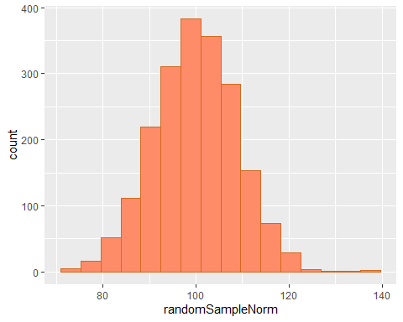

**Problem L.17 (REVISION)**

**Standards being revised: : L.17**

1. I wrongfully assumed that you could use dnorm similar to the way you would use pbinom or dpois. However, I did not realize that dnorm actually provide the density of the normal distribution at a specific quantile, so finding the sum would not work. The correct way to find the normal distribution of P (19 ≤ X ≤ 20) would be pnorm(20,18, 2) - pnorm(19,18, 2). The answer would be 0.1498823.
2. I accidentally mistyped 15 as 14 for the x value.The x- value should be 14 because normal distribution is continuous and should consist of all values up to 15. The correct code would be 1-pnorm(15,18,sqrt(4)), which equals 0.9331928.

#X ∼ Normal(18, 4)  
  
#a. P (X ≤ 12)  
normA <-pnorm(12,18,sqrt(4)) #calc  
print(normA)

## [1] 0.001349898

#b. P (19 ≤ X ≤ 20)  
normB <- pnorm(20,18, 2) - pnorm(19,18, 2) #calc  
  
print(normB)

## [1] 0.1498823

#c. P (X ≥ 15)  
normC <- 1-pnorm(15,18,sqrt(4)) #calc  
print(normC)

## [1] 0.9331928